Exam Three Sections
Multiple Choice: 40 points
- 20 questions at 2 point each
- 20 minutes

Sentence Revision 24 points
- 6 questions at 4 points each
- 15 minutes

Sentence Diagrams: 18 points
- 3 diagrams at 6 points each
- 20 minutes

Sentence Creation: 18 points
- 6 questions at 3 points each
- 10 minutes

Section A: Multiple Choice
Question One: Which of these is a Compound sentence containing two independent clauses? (2 pts)
Answer:
- Plumbers keep your pipes running smoothly and take pride in their work.
- They can install a sink, clear a drain, or replace your water heater.
- They always turn off the water before any project, and water pressure is carefully tested afterwards.
- If they do happen to flood they house, they always compensate you for the damage.

Question Two: Which of these sentences is punctuated correctly (following the strictest prescriptive rules)?
Answer:
- You cannot enter this restaurant, if you are not wearing shoes.
- Allowing bare feet is unsanitary the health department does not allow it.
- Since you have no shoes, I must ask you to leave.
- I am sorry; but that is our policy.

Question Three: Which of these best describes the aspect of the following sentence? (2 pts)
Sentence: I will have been playing bass for 25 years this winter.
Answer:_____
- Simple Aspect
- Progressive Aspect
- Perfect Progressive Aspect
- Perfect Aspect

Question Four: Which of these sentences is written in Past Perfect Progressive (Past Tense, Perfect Progressive Aspect)? (2 pts)
Answer:_____
- I have been working on a table.
- I had been working on a table.
- I was working on a table.
- I have worked on a table.

Section A2: Voice: 3 questions
Question Five: Which of these sentences is in passive voice? (2 pts)
Answer:_____
- My paper was very long
- My paper was impressive to my peers.
- My paper was accepted for publication.
- My idea had been making me so frustrated.

Question Six: Which of these sentences correctly transforms the passive voice sentence below into active voice (while maintaining all other elements)? (2 pts)
Sentence: The payment had been accepted by the agent. (past – perfect)
Answer:_____
- The agent had been accepting the payments.
- The agent has been accepting the payments.
- The agent had accepted the payments.
- The agent accepted the payments.

Question Seven: Which of the sentences below does NOT include a modal? (2 pts)
Answer:_____
- I do have the will to carry on.
- I must use all my strength.
- Victory shall be my reward.
- I can do it!

Question Eight: Which of the sentences below does NOT include an auxiliary verb? (2 pts)
Answer:_____
Sentence: Sometimes, people can be exceedingly irritating and silly.

- She does have an excellent point.
- Phong is being a real jerk.
- He has no excuse for his behavior.
- I simply won’t (will not) tolerate it any longer. (oops!)

Section B:
Sentence Revision
Question Nine:
Revise this sentence by transforming it to Past Perfect (Past Tense, Perfect Aspect).
Sentence: I am always happy about my cooking. Present – Simple
Answer: I had always been happy about my cooking.
Present I have always been happy about my cooking.

Question Ten:
Revise this sentence to change the voice from Active to Passive. Maintain the original tense and aspect in the new sentence.
Sentence: The nurses are considering a new medication for Janet.
Answer: A new medication is being considered for Janet (by the nurses).

Questions Eleven:
Combine the two sentences below by adding a coordinating conjunction to form a compound sentence. Be sure to punctuate the new sentence correctly.
Sentence: A horse named Clever Hans seemed to be able to answer questions by tapping his hooves. He was only responding to his owner’s body language.
A horse named Clever Hans seemed to be able to answer questions by tapping his hooves, but he was only responding to his owner’s body language.

A horse named Clever Hans seemed to be able to answer questions by tapping his hooves, but he was only responding to his owner’s body language.

Sentence Diagrams: 18 points (3 diagrams, 6 points each)
On the following pages, you will find three sentences. Each sentence is worth six points.
Complete a diagram in the style we have been practicing. Please draw the diagrams by hand or using the digital tool on our Canvas page. I will grade generously, and I am not extremely concerned about the specific codes you use, so long as you label things clearly and structure the tree accurately. I am concerned that you draw the lines to the appropriate “level” on the diagram.
- Please be sure to include a node for each phrase (NP, VP, ADJP, ADVP, PP). When needed, please include an additional Clause (S) level to indicate sentences with coordination or subordination.
- When needed, please include an additional phrase level to indicate a complex phrase substituting for a different function. For instance, if you have a verb phrase (form) serving as a subject (function), diagram it as NP-VP-V.

I have provided five empty pages in the back of the exam if you need them for corrections or practice. Please just clearly indicate which is your final answer!

Question Twelve: Please diagram this sentence. (6 pts)
Sentence: Since I do enjoy the outdoors, I should have ridden a snowmobile before now..
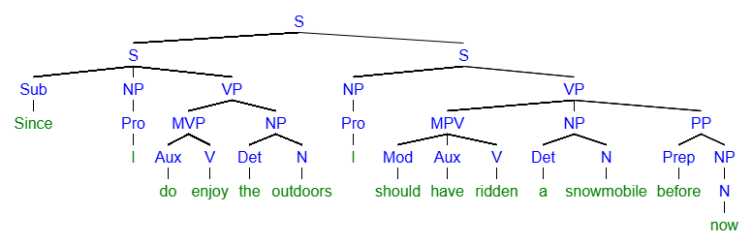
[S [S [Sub Since] [NP [Pro I]] [VP [MVP [Aux do] [V enjoy]] [NP [Det the] [N outdoors]]]] [S [NP [Pro I]] [VP [MPV [Mod should] [Aux have] [V ridden]]] [NP [Det a] [N snowmobile]] [PP [Prep before] [NP [N now]
Question Thirteen: Please diagram this sentence. (6 pts)
During the fire, many homes were destroyed a few were saved.
During the fire, many homes were destroyed, a few were saved.
During the fire, many homes were destroyed. A few were saved.
During the fire, many homes were destroyed; a few were saved.
During the fire, many homes were destroyed, but a few were saved.
During the fire, many homes were destroyed - a few were saved.
During the fire, many homes were destroyed… a few were saved.
During the fire, many homes were destroyed while a few were saved.
During the fire, many homes were destroyed; however, a few were saved.

Sentence: Sentence: During the fire, many homes were destroyed, but a few were saved.
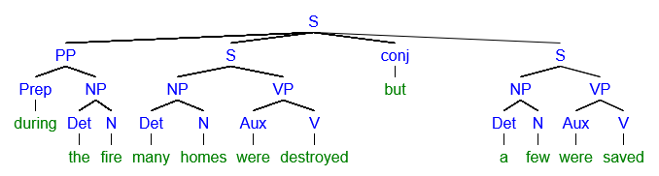
[S [PP [Prep during] [NP [Det the] [N fire]]] [S [NP [Det many] [N homes]] [VP [Aux were] [V destroyed]]] [conj but] [S [NP [Det a] [N few]] [VP [Aux were] [V saved]
Question Fourteen: Please diagram this sentence. (6 pts)
Sentence: Sentence I could have stopped her or at least should have delayed her for a while.
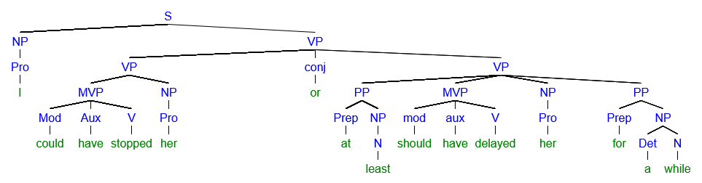
[S [NP [Pro I]] [VP [VP [MVP [Mod could] [Aux have] [V stopped]] [NP [Pro her]]] [conj or] [VP [PP [Prep at] [NP [N least]]] [MVP [mod should] [aux have] [V delayed]] [NP [Pro her]] [PP [Prep for] [NP [Det a] [N while]

Section D: Sentence Creation
For section D and the Bonus, please write all the new sentences about a movie, book, or TV show you like. Feel free to reuse the same ideas and characters from the movie, book, or TV show as many times as you like. Feel free to copy from/mirror your earlier sentences in this activity. Be sure to punctuate the sentences correctly!
Name the movie, book or TV show here:___________________

Question Fifteen: (3 points)
Write two sentences containing this element:
- Two sentences connected with a Conjunctive Adverb
  - June had the baby with Nick. Mr. Waterford, however, thought the baby was his.

Question Sixteen: (3 points)
Write a sentence containing this element
- A passive voice verb phrase in present tense\
  - A new necklace is bought by Celena.

Question Seventeen: (3 points)
Write a sentence containing this element
- A verb in past perfect progressive
  - The cat was meowing. Past Progressive
  - The cat had been meowing – Past Perfect Progessive.

Bonus: 2 Questions, Twelve Points
Bonus Question One: 6 points
Rewrite the following passage by transforming all the sentences to passive voice, past tense, perfect aspect).
- You can choose to leave Jenna in the sentences or remove her.

Jenna chops fresh carrots, celery, and onions on the cutting board. She tosses the vegetables into a large pot and adds chunks of seasoned chicken. As the mixture simmers, she stirs it gently and skims off the foam. The rich aroma of herbs fills the kitchen and makes her smile. Finally, she tastes the broth, adds a pinch of salt, and lets it cook to perfection. After all that work, Jenna spills the soup on the floor!
Fresh carrots, celery, and onions had been chopped on the cutting board. The vegetables and chunks of seasoned chicken had been tossed into a large pot. As the mixture simmered, it had been stirred, and the foam had been skimmed off. The kitchen had been filled with the rich aroma of herbs and had made her smile. Finally, the broth had been tasted, a pinch of salted had been added, and it had been cooked to perfection. After all that work, the soup had been spilled on the floor.

